
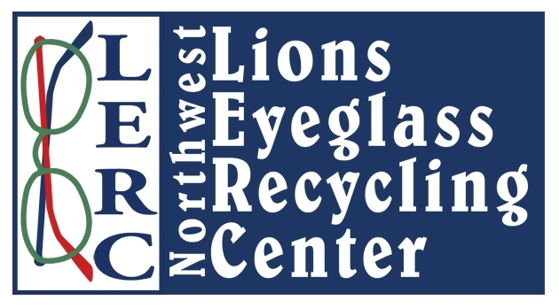

9013 Mullen Road SE

Olympia, WA 98513
360-923-2075
www.lionsnwlerc.org

Request for Eyeglasses

Name of organization: _________________________________________________________________

Address: ____________________________________________________________________________

Phone number: ____________________ Email: __________________________________________

Affiliation: __________________________________________________________________________

Point of contact: _________________________ Point of contact’s phone number: _________________

Number of eyeglasses requested: ____________________ Date required: ________________________

Location/Country of mission: ___________________________________________________________

Mission dates: ___________________________________

Names of optometric professionals accompanying the mission: _________________________________

___________________________________________________________________________________

___________________________________________________________________________________

Describe your program. Who will receive eyeglasses? How will eyeglasses be dispensed? If Lions clubs are involved, what clubs are participating?

____________________________________________________________________________________

____________________________________________________________________________________

____________________________________________________________________________________

____________________________________________________________________________________

____________________________________________________________________________________

9013 Mullen Road SE

Olympia, WA 98513
360-923-2075
www.lionsnwlerc.org

Agreement

In exchange for the eyeglasses requested from Northwest Lions Eyeglass Recycling Center (NWLERC), we agree to the following terms and conditions:

- To assure that the eyeglasses are provided free-of-charge to needy people.
- To pick up the eyeglasses at NWLERC (or its designated storage facility) or to pay for shipping.
- To arrange for any necessary customs clearances.
- To provide a report within 14 days of the completion of the mission, with the number of people served and the number fitted with eyeglasses.
- To provide photographs (preferably digital) of the mission and to allow NWLERC to use the photographs in any manner determined to be appropriate by the Executive Committee of NWLERC.
- To acknowledge NWLERC’s donation of the eyeglasses in the organization’s public relations and reports to other agencies or organizations.
- To ensure, to the maximum extent possible, that final recipients of the eyeglasses are aware their eyeglasses were collected and processed by volunteer members of Lions Clubs International and Lions Clubs of the Northwest.

_____________________________ _______________

Signature Date

_________________________________________________________
Name and Title

_________________________________________________________
Name of Organization

